Assessments
Section A: CONCEPT APPLICATION

S1: SCENARIO
You are a data analyst at a food delivery platform. The operations team needs a report
showing which restaurant partners earned more than Rs 1,00,000 in total revenue last
month — but only for restaurants that received at least 50 orders.
Question: Explain how you would use GROUP BY and HAVING together to produce this report.
Why is HAVING more appropriate than WHERE for filtering on aggregated values? What would
break in your query if you replaced HAVING with WHERE?
S2
Use mydb;
drop table if exists Orders;
Create Table Orders
(Order_id int, Restuarant_id int, total_amount Decimal(10,2), Order_date date);
Insert into Orders
Values (1, 101, 2500.00, '2026-09-05'),
(2, 101, 3000.00, '2026-09-06'),
(3, 102, 1500.00, '2026-09-08'),
(4, 102, 2000.00, '2026-09-10'),
(5, 103, 2500.00, '2026-09-12');
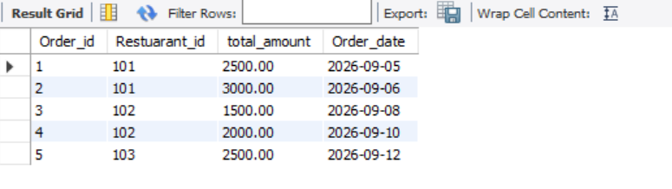
select * from Orders;
Select count(order_id) as Total_Orders, sum(total_amount) as total_revenue,Restuarant_id from Orders
where order_date >='2026-09-01'
and Order_date < '2026-10-01'
group by Restuarant_id
having Total_orders > 50
and Total_revenue > 100000;

S 2:SCENARIO
You are building a customer insights report for a food delivery app. The marketing team
needs a list of every registered customer and their most recent order details — even for
customers who have never placed an order.
Question: Which type of JOIN would you use to ensure all customers appear in the result,
including those with no orders? Justify your choice by comparing it with INNER JOIN, and explain
specifically what data would be lost if INNER JOIN were used instead.

SQL
-- 1. Create the Customers table
CREATE TABLE Customers (
customer_id INT PRIMARY KEY,
customer_name VARCHAR(100) NOT NULL,
email VARCHAR(100) UNIQUE,
registration_date DATE
);

-- 2. Create the Orders table
CREATE TABLE Orders (
order_id INT PRIMARY KEY,
customer_id INT NOT NULL,
order_date DATETIME NOT NULL,
order_amount DECIMAL(10, 2) NOT NULL,
CONSTRAINT fk_customer_orders
FOREIGN KEY (customer_id)
REFERENCES Customers(customer_id)
ON DELETE CASCADE
);
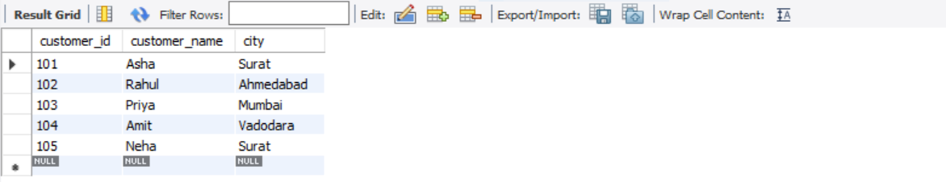

WITH RankedOrders AS
( SELECT order_id, customer_id, order_date, order_amount, ROW_NUMBER() OVER (PARTITION BY customer_id ORDER BY order_date DESC) AS rn FROM Orders )

SELECT
c.customer_id, c.customer_name, c.email, r.order_id AS most_recent_order_id, r.order_date AS most_recent_order_date, r.order_amount AS most_recent_order_amount FROM Customers c LEFT JOIN RankedOrders r ON c.customer_id = r.customer_id AND r.rn = 1;
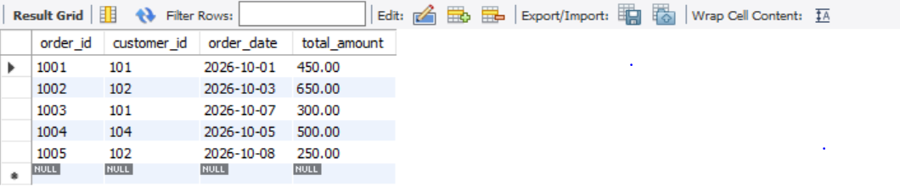

S3
S 3. SCENARIO
You are designing a delivery performance dashboard. The business wants to identify
delivery agents whose average delivery time is faster than the overall platform average,
without using a temporary table or creating a new view.
Question: Describe how you would write a subquery to find these agents. What type of
subquery is most appropriate here — scalar, row, or table — and why? What would happen if you
tried to place this subquery in the SELECT clause instead of the WHERE clause?

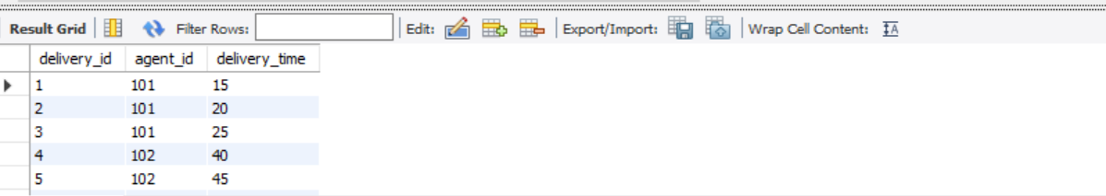

use mydb;
select * from deliveries ;
CREATE TABLE deliveries (
delivery_id INT PRIMARY KEY,
agent_id INT NOT NULL,
delivery_time INT NOT NULL -- Time in minutes
);
INSERT INTO deliveries (delivery_id, agent_id, delivery_time) VALUES
-- Agent 1 (Fast Agent - Average: 20 mins)
(1, 101, 15),
(2, 101, 20),
(3, 101, 25),

-- Agent 2 (Slow Agent - Average: 45 mins)
(4, 102, 40),
(5, 102, 45),
(6, 102, 50),

-- Agent 3 (Very Fast Agent - Average: 12 mins)
(7, 103, 10),
(8, 103, 12),
(9, 103, 14);

QUESTION 1 & 2: Subquery Type and Why -- Type: SCALAR SUBQUERYS4
SELECT
agent_id,
AVG(delivery_time) AS avg_agent_delivery_time
FROM
deliveries
GROUP BY
agent_id
HAVING
AVG(delivery_time) < (
-- Scalar Subquery: Calculates overall platform average delivery time
SELECT AVG(delivery_time)
FROM deliveries
)

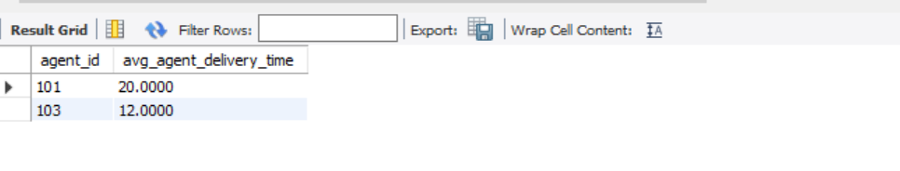
QUESTION 3: What happens if placed in the SELECT clause instead?
SELECT
agent_id,
AVG(delivery_time) AS avg_agent_delivery_time,
-- This evaluates as a computed column for every row, not a filter:
(SELECT AVG(delivery_time) FROM deliveries) AS overall_platform_average
FROM
deliveries
GROUP BY
agent_id;

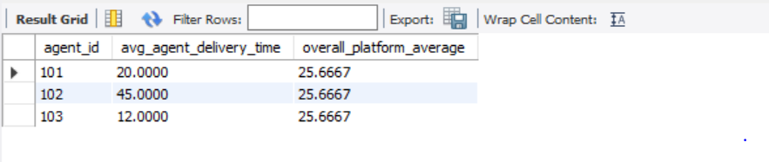

S4
S.4 SCENARIO
You are analysing order data for a food delivery company. The product team wants to
rank the top 3 highest-revenue restaurants within each city. Two restaurants in Surat
have the exact same revenue figure and you must decide how to number them.
Question: Compare RANK() and DENSE_RANK() window functions for this use case. Which would
you choose and why? Provide a brief example showing how each function would number three
restaurants where two share the same revenue, and explain the practical impact of that
difference on the product team's report.

-- Step 1: Create the underlying tables
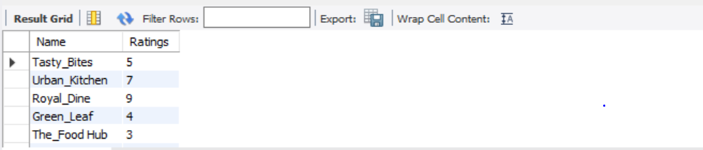
S5
SELECT - Step 1: Create the underlying tables
CREATE TABLE restaurants
( restaurant_id INT PRIMARY KEY,
restaurant_name VARCHAR(100) NOT NULL, city VARCHAR(50) NOT NULL );

CREATE TABLE orders ( order_id INT PRIMARY KEY, restaurant_id INT NOT NULL, total_amount DECIMAL(10, 2) NOT NULL, order_date TIMESTAMP NOT NULL, CONSTRAINT fk_restaurant FOREIGN KEY (restaurant_id) REFERENCES restaurants(restaurant_id) );

Step 2: Aggregate revenue and rank top 3 restaurants per city WITH RestaurantRevenue AS
( SELECT
r.city,
r.restaurant_id,
r.restaurant_name,
SUM(o.total_amount) AS revenue
FROM restaurants r
JOIN orders o ON r.restaurant_id = o.restaurant_id
GROUP BY r.city, r.restaurant_id, r.restaurant_name),
RankedRestaurants AS (Select city,restaurant_id,restaurant_name,revenue,
RANK() OVER (PARTITION BY city ORDER BY revenue DESC) AS revenue_rank
FROM RestaurantRevenue)
Select
city,
restaurant_id,
restaurant_name,
revenue,
revenue_rank
FROM RankedRestaurants
WHERE revenue_rank <= 3
ORDER BY city, revenue_rank, revenue DESC;


S5: SCENARIO
You are writing a CRM query for a food delivery startup. The customer success team
wants each customer labelled as 'Platinum', 'Gold', or 'Standard' based on total lifetime
spend — above Rs 5,000, between Rs 2,000 and Rs 5,000, and below Rs 2,000
respectively — directly in the query output without creating a new table.
Question: Explain how you would use CASE WHEN to generate this classification column. If a
customer's total spend is exactly Rs 5,000, which tier will they fall into, and how does the order of
your WHEN conditions control that outcome
use mydb;
drop table if exists cust;
CREATE TABLE cust (
customer_id INT,
customer_name VARCHAR(50),
total_spend DECIMAL(10,2)
);
INSERT INTO cust VALUES
(1, 'Amit', 6500),
(2, 'Priya', 5000),
(3, 'Rahul', 3000),
(4, 'Neha', 1500),
(5, 'Karan', 1000);
select * from cust;

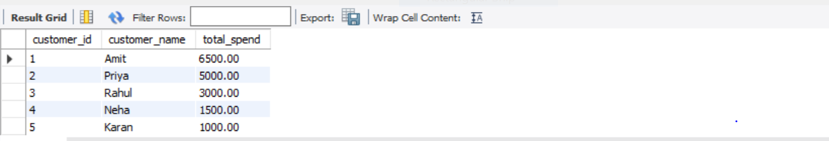
use mydb;
select * from customer;
SELECT
customer_id,
customer_name,
total_spend,
CASE
WHEN total_spend > 5000 THEN 'Platinum'
WHEN total_spend >= 2000 THEN 'Gold'
ELSE 'Standard'
END AS customer_tier FROM customers;
S6: SCENARIO
You are optimising a slow-running analytics query for a food delivery platform. The
query joins four large tables and applies a GROUP BY across 10 million rows, taking over
30 seconds. A colleague suggests adding an index on the JOIN column used most
frequently.
Question: Explain what a database index does at the engine level and why it would speed up
this specific query. Are there scenarios where adding an index could actually hurt performance?
What trade-off must you evaluate before indexing every column in a large table?

Ans: Answer: Database Indexing and Query Performance

1. What does a database index do at the engine level?
A database index is a data structure that helps the database engine find specific rows quickly without scanning the entire table.
Most relational databases use structures such as a B-tree index. The index stores indexed column values along with pointers or references to the corresponding rows.
For example, if a food delivery database has 10 million order records, an index on customer_id helps the database locate orders for a particular customer more efficiently.
Without an index, the database may perform a full table scan, checking many or all rows. With a suitable index, it can navigate directly to the relevant entries.

2. Why would an index speed up this query?
The query joins four large tables and groups 10 million rows, taking over 30 seconds. An index on a frequently used JOIN column can help in the following ways:
- Faster JOIN operations: The database can find matching rows in another table more efficiently.
- Fewer rows scanned: An appropriate index may reduce the number of records the engine needs to examine.
- Improved filtering: If the query includes WHERE conditions on indexed columns, the engine may retrieve only the required rows.
- Better overall execution time: Reducing the cost of finding matching records can make the entire query faster.
However, an index on the JOIN column will not automatically eliminate the cost of processing 10 million rows for GROUP BY. The actual improvement depends on the query execution plan, data distribution, and indexes on the relevant columns.

3. Can adding an index hurt performance?
Yes. Adding an index can sometimes reduce performance.
- Slower INSERT operations: The database must update the index whenever new rows are inserted.
- Slower UPDATE and DELETE operations: Changes to indexed values require index maintenance.
- Extra storage: Indexes consume additional disk space and memory.
- Poor index selection: An index on a column with very few distinct values may not help much if the database still needs to read a large portion of the table.
- More maintenance overhead: Too many indexes can increase the cost of database operations and maintenance.

4. What trade-off must you evaluate before indexing every column?
The main trade-off is read performance versus write performance, storage, and maintenance cost.
Advantages of indexes | Disadvantages of indexes
Faster data retrieval | Additional storage required
Faster matching for suitable JOINs  Potentially faster filtering and sorting  Improved performance for some queries | Slower INSERT, UPDATE, and DELETE operations  Index maintenance overhead  Too many indexes can waste resources
Best practice: Do not index every column. Identify the columns frequently used in JOINs, WHERE conditions, and sometimes GROUP BY or ORDER BY operations. Then examine the execution plan and measure query performance before and after adding suitable indexes.

Conclusion
A database index improves data retrieval by helping the engine locate rows without scanning an entire table. In this food delivery scenario, a suitable index on the JOIN columns may reduce the time required to match records across four large tables. However, indexes consume storage and slow down data modifications, so they should be chosen based on actual query patterns and measured performance.

SECTION B
# Task 1: Menu & Order Explorer
Write a series of SELECT queries on a food delivery orders table to retrieve, filter, and sort data
using core SQL clauses.
Create a table named food_orders with columns: order_id, customer_name,
restaurant_name, item_ordered, quantity, price_per_item, order_date, and city. Insert at
least 8 rows spanning at least 3 cities.
Write a query to retrieve all orders placed in the city of 'Mumbai', sorted by price_per_item in
descending order.
Write a query to return all distinct restaurant names that have received at least one order.
Write a query to list the top 5 most expensive individual orders using ORDER BY and LIMIT.
Ans:
Create database mydb;
Use mydb;
DROP TABLE IF EXISTS ORDERS;
select * from food_orders;
Create table food_orders
(order_id int,
customer_name varchar (70),
restaurant_name varchar (80),
item_ordered varchar(100),
quantity int,
price_per_item decimal (10,2),
order_date date,
city varchar(100));

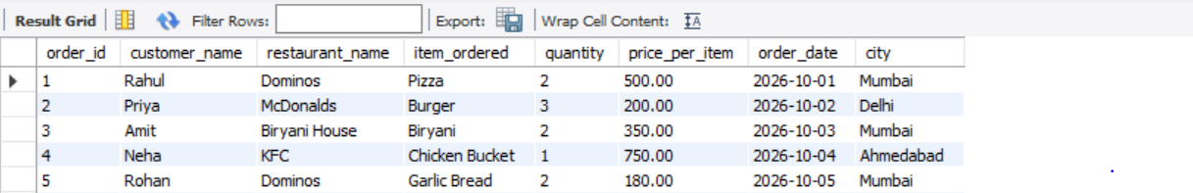

Insert into food_orders
(order_id, customer_name, restaurant_name, item_ordered,
quantity, price_per_item, order_date, city)
values
(1, 'Rahul', 'Dominos', 'Pizza', 2, 500.00, '2026-10-01', 'Mumbai'),
(2, 'Priya', 'McDonalds', 'Burger', 3, 200.00, '2026-10-02', 'Delhi'),
(3, 'Amit', 'Biryani House', 'Biryani', 2, 350.00, '2026-10-03', 'Mumbai'),
(4, 'Neha', 'KFC', 'Chicken Bucket', 1, 750.00, '2026-10-04', 'Ahmedabad'),
(5, 'Rohan', 'Dominos', 'Garlic Bread', 2, 180.00, '2026-10-05', 'Mumbai'),
(6, 'Sneha', 'Pizza Hut', 'Paneer Pizza', 1, 600.00, '2026-10-06', 'Delhi'),
(7, 'Vikas', 'Biryani House', 'Chicken Biryani', 3, 450.00, '2026-10-07', 'Ahmedabad'),
(8, 'Pooja', 'KFC', 'Burger Meal', 2, 400.00, '2026-10-08', 'Mumbai');

Select city,Order_id, price_per_item from Food_orders
where city = "Mumbai"
Order by Price_per_item desc;

®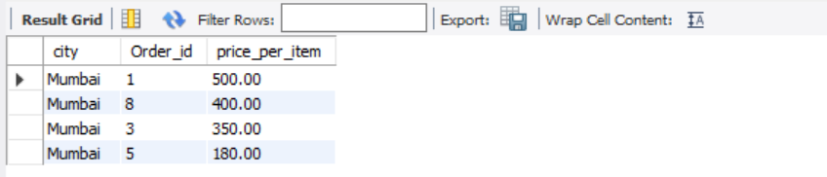

select distinct(restaurant_name) from food_orders;
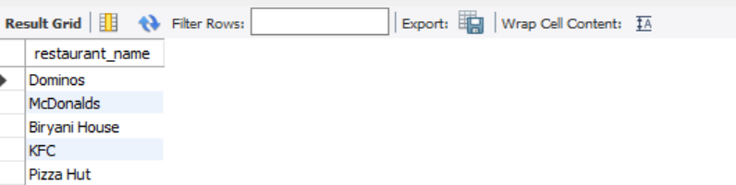

select price_per_item from food_orders
order by price_per_item desc limit 5;

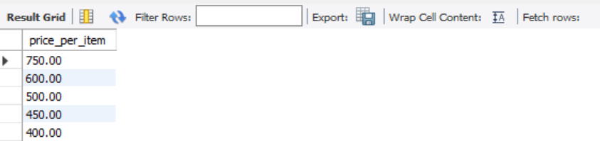

# TASK 2 : Restaurant Revenue Summary
Use aggregate functions and GROUP BY with HAVING to produce a restaurant-level revenue
and order-count summary from a delivery orders table.
Create a table named delivery_orders with columns: order_id, restaurant_name, city,
total_amount, order_status, and order_date. Insert at least 10 rows covering at least 4
different restaurants.
Write a query using SUM, COUNT, and AVG to calculate total revenue, total orders, and average
order value per restaurant.
Add a HAVING clause to return only restaurants whose total revenue exceeds Rs 5,000.
Extend the SELECT list with a CASE WHEN expression that labels each qualifying restaurant as
'High Revenue' if total revenue is above Rs 10,000, or 'Moderate Revenue' otherwise.
Ans:
use mydb;
select * from delivery_orders;
CREATE TABLE delivery_orders (
order_id INT PRIMARY KEY,
restaurant_name VARCHAR(100),
city VARCHAR(50),
total_amount DECIMAL(10,2),
order_status VARCHAR(30),
order_date DATE
);
INSERT INTO delivery_orders
(order_id, restaurant_name, city, total_amount, order_status, order_date)
VALUES
(1, 'Pizza Hut', 'Mumbai', 1200, 'Delivered', '2026-09-05'),
(2, 'Pizza Hut', 'Mumbai', 1500, 'Delivered', '2026-09-06'),
(3, 'Pizza Hut', 'Pune', 1800, 'Delivered', '2026-09-10'),
(4, 'Dominos', 'Mumbai', 2000, 'Delivered', '2026-09-07'),
(5, 'Dominos', 'Pune', 2500, 'Delivered', '2026-09-08'),
(6, 'Dominos', 'Mumbai', 1000, 'Cancelled', '2026-09-12'),
(7, 'McDonalds', 'Ahmedabad', 800, 'Delivered', '2026-09-09'),
(8, 'McDonalds', 'Ahmedabad', 1000, 'Delivered', '2026-09-11'),
(9, 'Swiggy Restaurant', 'Mumbai', 3000, 'Delivered', '2026-09-13'),
(10, 'Swiggy Restaurant', 'Pune', 3500, 'Delivered', '2026-09-14');

Select restaurant_name, sum(total_amount) as total_revenue, count(order_id) as total_orders, avg(total_amount) as average_order_value from delivery_orders
where order_status = "Delivered"
group by restaurant_name
HAVING SUM(total_amount) > 3000
AND COUNT(order_id) >= 2
ORDER BY total_revenue DESC;
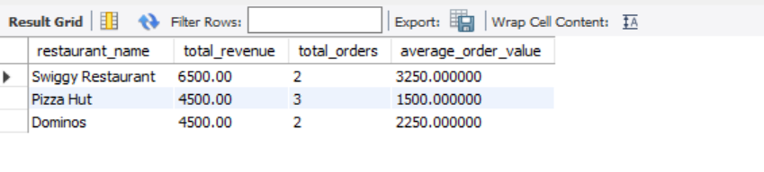

# Task 3: Customer–Order–Restaurant Joined Report
Write JOIN queries across three related tables — customers, restaurants, and orders — to
produce a combined order report that handles missing records gracefully.
Create three tables: customers (customer_id, name, city, phone), restaurants (restaurant_id,
name, cuisine_type, city), and orders (order_id, customer_id, restaurant_id, amount,
order_date). Insert at least 6 rows per table and intentionally include at least 2 customers who
have placed no orders.
Write an INNER JOIN query to list each order alongside the placing customer's name and the
fulfilling restaurant's name.
Write a LEFT JOIN query to list all customers — including those with no orders — with NULL
appearing in order columns where no order exists.
Add a WHERE condition to the joined result to show only orders where both the customer and
the restaurant belong to the same city.
# Create the three tables:
use mydb;
Customers table
select * from customers;
CREATE TABLE customers (
customer_id INT PRIMARY KEY,
name VARCHAR(50),
city VARCHAR(50),
phone VARCHAR(15));
INSERT INTO customers VALUES
(1, 'Amit', 'Mumbai', '9876500001'),
(2, 'Priya', 'Pune', '9876500002'),
(3, 'Rahul', 'Ahmedabad', '9876500003'),
(4, 'Neha', 'Delhi', '9876500004'),
(5, 'Karan', 'Mumbai', '9876500005'),
(6, 'Sneha', 'Pune', '9876500006');

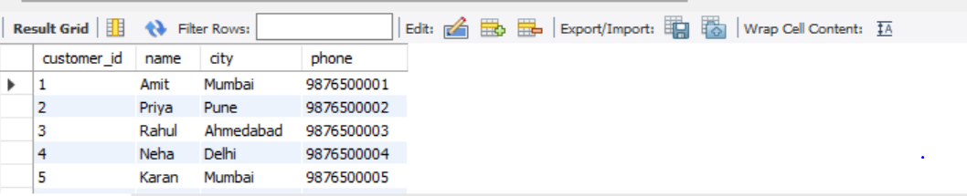
Restaurants table:
Select * from restaurants;
CREATE TABLE restaurants (
restaurant_id INT PRIMARY KEY,
name VARCHAR(50),
cuisine_type VARCHAR(50),
city VARCHAR(50))

INSERT INTO restaurants VALUES
(101, 'Spice Garden', 'Indian', 'Mumbai'),
(102, 'Pizza Corner', 'Italian', 'Pune'),
(103, 'Gujarati Rasoi', 'Gujarati', 'Ahmedabad'),
(104, 'Delhi Bites', 'North Indian', 'Delhi'),
(105, 'Burger Hub', 'Fast Food', 'Mumbai'),
(106, 'South Kitchen', 'South Indian', 'Chennai');


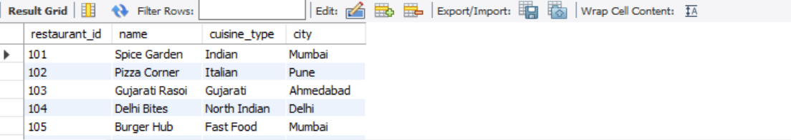
Orders table:
use mydb;
select * from orders;
CREATE TABLE orders (
order_id INT PRIMARY KEY,
customer_id INT,
restaurant_id INT,
amount DECIMAL(10,2),
order_date DATE,
FOREIGN KEY (customer_id) REFERENCES customers(customer_id),
FOREIGN KEY (restaurant_id) REFERENCES restaurants(restaurant_id)
);
INSERT INTO orders VALUES
(1001, 1, 101, 450.00, '2026-10-01'),
(1002, 2, 102, 650.00, '2026-10-02'),
(1003, 3, 103, 350.00, '2026-10-03'),
(1004, 4, 104, 800.00, '2026-10-04'),
(1005, 1, 105, 250.00, '2026-10-05'),
(1006, 2, 106, 500.00, '2026-10-06');


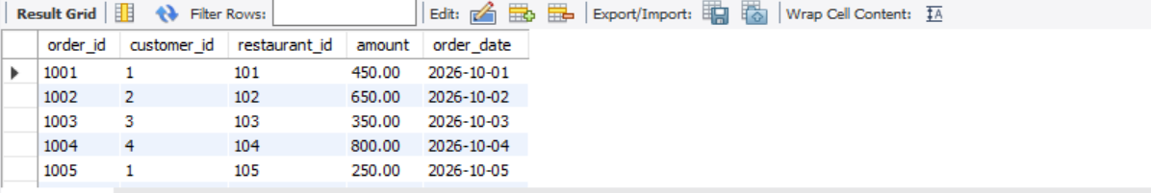
3. INNER JOIN – Display each order with customer and restaurant names
SELECT
o.order_id,
c.name AS customer_name,
r.name AS restaurant_name,
o.amount,
o.order_date
FROM orders o
INNER JOIN customers c
ON o.customer_id = c.customer_id
INNER JOIN restaurants r
ON o.restaurant_id = r.restaurant_id;

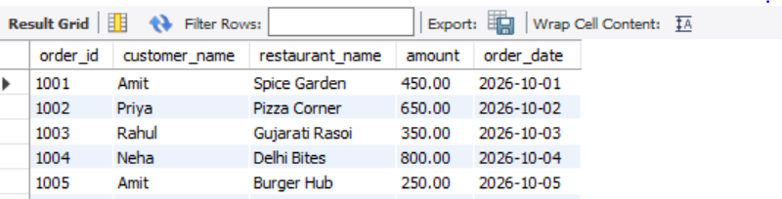

4. LEFT JOIN – Display all customers, including those without orders
SELECT
c.customer_id,
c.name AS customer_name,
c.city AS customer_city,
o.order_id,
o.amount,
o.order_date,
r.name AS restaurant_name
FROM customers c
LEFT JOIN orders o
ON c.customer_id = o.customer_id
LEFT JOIN restaurants r
ON o.restaurant_id = r.restaurant_id;


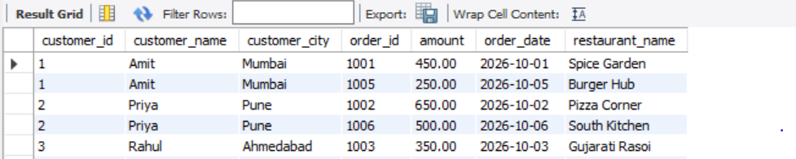

5. WHERE condition – Show orders where customer and restaurant belong to the same city
SELECT
o.order_id,
c.name AS customer_name,
c.city AS customer_city,
r.name AS restaurant_name,
r.city AS restaurant_city,
o.amount
FROM orders o
INNER JOIN customers c
ON o.customer_id = c.customer_id
INNER JOIN restaurants r
ON o.restaurant_id = r.restaurant_id
WHERE c.city = r.city;

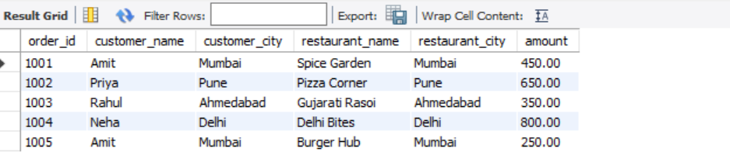

# TASK 4: Delivery Agent Performance Ranking
Use a CTE, window functions, and a subquery together to rank delivery agents by speed and
flag those performing below the platform average.
Create a table named deliveries with columns: delivery_id, agent_name, restaurant_name,
delivery_time_mins, and order_date. Insert at least 10 rows across at least 4 delivery agents,
with varied delivery times.
Write a CTE named agent_stats that calculates each agent's average delivery time across all
their deliveries.
Using the CTE result, apply RANK() OVER (ORDER BY avg_delivery_time ASC) to rank agents
from fastest to slowest.
Add a scalar subquery to compute the overall platform average delivery time, then use CASE
WHEN in the final SELECT to label each agent 'On Track' if their average is at or below the
platform average, or 'Needs Improvement' if it is above.

Ans:
use mydb;
Select * from deliveries;
CREATE TABLE deliveries (
delivery_id INT PRIMARY KEY,
agent_name VARCHAR(50),
restaurant_name VARCHAR(100),
delivery_time_mins INT,
order_date DATE
);

INSERT INTO deliveries
(delivery_id, agent_name, restaurant_name,
delivery_time_mins, order_date)
VALUES
(1, 'Amit', 'Pizza Hub', 20, '2026-10-01'),
(2, 'Amit', 'Burger Point', 25, '2026-10-02'),
(3, 'Amit', 'Food Corner', 22, '2026-10-03'),

(4, 'Priya', 'Pizza Hub', 30, '2026-10-01'),
(5, 'Priya', 'Burger Point', 28, '2026-10-02'),
(6, 'Priya', 'Food Corner', 32, '2026-10-03'),

(7, 'Rahul', 'Pizza Hub', 15, '2026-10-01'),
(8, 'Rahul', 'Burger Point', 18, '2026-10-02'),
(9, 'Rahul', 'Food Corner', 17, '2026-10-03'),

(10, 'Neha', 'Pizza Hub', 35, '2026-10-01'),
(11, 'Neha', 'Burger Point', 40, '2026-10-02'),
(12, 'Neha', 'Food Corner', 38, '2026-10-03');


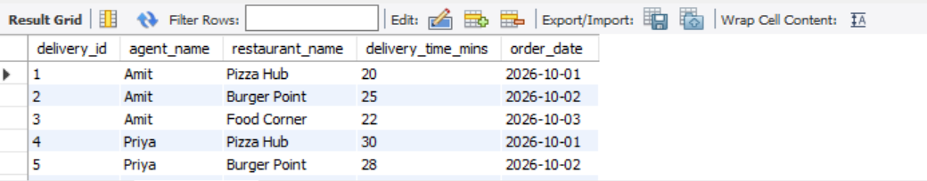

SQL query using CTE, RANK(), scalar subquery, and CASE WHEN

WITH agent_stats AS (
SELECT
agent_name,
AVG(delivery_time_mins) AS avg_delivery_time
FROM deliveries
GROUP BY agent_name)
SELECT
agent_name,
ROUND(avg_delivery_time, 2) AS avg_delivery_time,
RANK() OVER (
ORDER BY avg_delivery_time ASC ) AS agent_rank,(SELECT AVG(delivery_time_mins)
FROM deliveries) AS platform_avg_delivery_time,
CASE
WHEN avg_delivery_time <= (
SELECT AVG(delivery_time_mins)
FROM deliveries)
THEN 'On Track'
ELSE 'Needs Improvement'
END AS performance_status
FROM agent_stats
ORDER BY agent_rank;

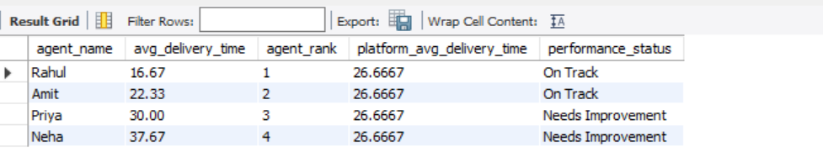
- CTE (agent_stats): Calculates the average delivery time for each agent using AVG() and GROUP BY.
- Window function (RANK()): Ranks agents from fastest to slowest. A lower average delivery time receives a better rank.
- Scalar subquery: Calculates the overall platform average delivery time across all deliveries.
- CASE WHEN: Labels an agent On Track when their average is less than or equal to the platform average; otherwise, it returns Needs Improvement.
- ORDER BY agent_rank: Displays the fastest agent first.
Conclusion: Rahul is the fastest delivery agent, with an average of 16.67 minutes. Rahul and Amit are performing at or better than the platform average, while Priya and Neha need improvement.

C: Section C – Mini Capstone Project
Mini Project: Food Delivery Analytics — SQL Backend
Objective:
Build a complete SQL backend for a food delivery analytics system by designing a multi-table
schema and writing a suite of queries that combines JOINs, aggregations, window functions,
CASE WHEN classification, CTEs, and a saved View to answer real business questions.
Your project must:
Design a schema with at least four related tables: customers, restaurants, orders, and
delivery_agents. Define appropriate PRIMARY KEY and FOREIGN KEY constraints and insert at
least 10 rows per table with realistic food delivery data across at least 3 cities.
Write a revenue report query using GROUP BY, HAVING, and aggregate functions (SUM, COUNT,
AVG) that returns total orders and total revenue per restaurant, filtered to include only
restaurants with more than 3 orders.
Write a customer segmentation query using CASE WHEN to classify each customer as
'Platinum' (spend above Rs 5,000), 'Gold' (Rs 2,000–Rs 5,000), or 'Standard' (below Rs 2,000)
based on their total spend, ordered from highest to lowest spender.
Write a window function query using DENSE_RANK() OVER (PARTITION BY city ORDER BY
total_revenue DESC) to identify the top 3 performing restaurants in each city, and a separate
query using ROW_NUMBER() to find each customer's single most recent order.
Create a SQL VIEW named vw_daily_order_summary that JOINs all four tables and returns:
order_date, customer_name, restaurant_name, agent_name, order_amount, and
delivery_time_mins. Query the view to display only orders placed in the last 7 days.

Ans:1. Create the database and tables
The database contains four tables:
- customers — customer information.
- restaurants — restaurant details and cities.
- delivery_agents — delivery agent information.
- orders — order amount, date, status, and delivery time, connected to the other three tables.
CREATE DATABASE food_delivery_analytics;
USE food_delivery_analytics;
ns: D Section
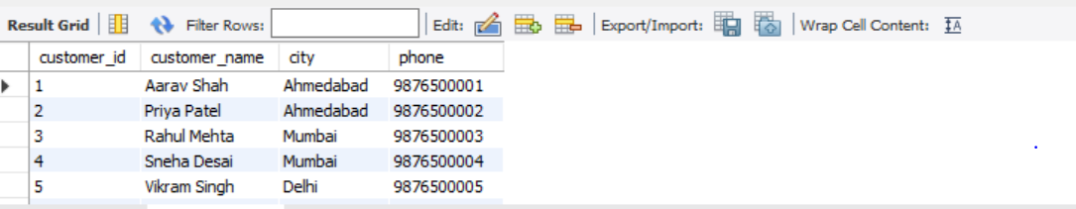

B. Restaurants:


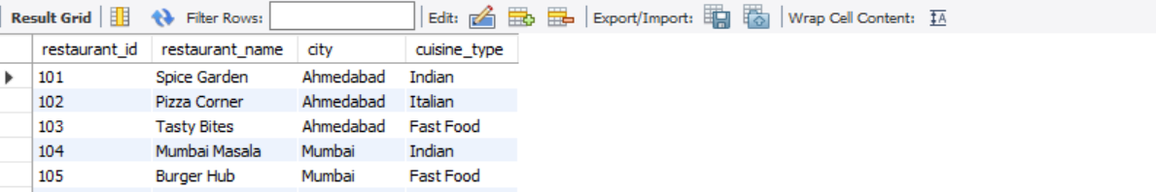

C. Delivery agents:

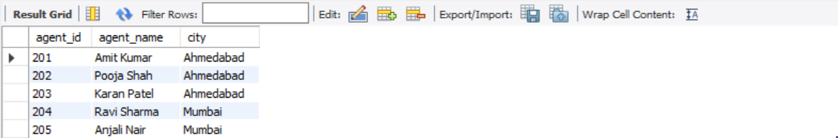

D. Orders:

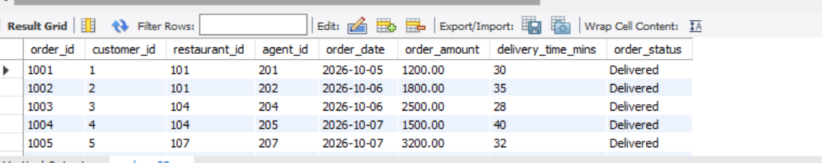

Revenue report per restaurant
SELECT
r.restaurant_id,
r.restaurant_name,
COUNT(o.order_id) AS total_orders,
SUM(o.order_amount) AS total_revenue,
AVG(o.order_amount) AS average_order_value
FROM restaurant r
INNER JOIN orders o
ON r.restaurant_id = o.restaurant_id
GROUP BY
r.restaurant_id,
r.restaurant_name
HAVING COUNT(o.order_id) > 3
ORDER BY total_revenue DESC;


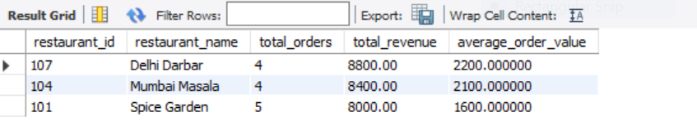

Customer segmentation using CASE WHEN
SELECT
c.customer_id,
c.customer_name,
COALESCE(SUM(o.order_amount), 0) AS total_spend,
CASE
WHEN COALESCE(SUM(o.order_amount), 0) > 5000
THEN 'Platinum'
WHEN COALESCE(SUM(o.order_amount), 0) >= 2000
THEN 'Gold'
ELSE 'Standard'
END AS customer_segment
FROM customer c
LEFT JOIN orders o
ON c.customer_id = o.customer_id
GROUP BY
c.customer_id,
c.customer_name
ORDER BY total_spend DESC;


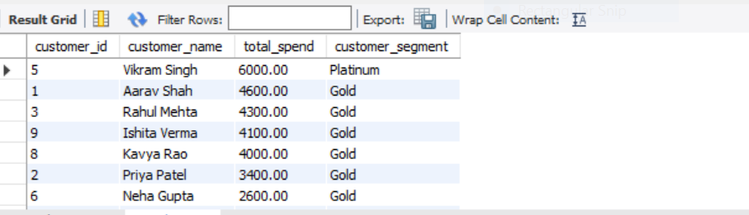

Window function: Top 3 restaurants in each city
WITH restaurant_revenue AS (SELECT
r.restaurant_id,
r.restaurant_name,
r.city,
COALESCE(SUM(o.order_amount), 0) AS total_revenue
FROM restaurant r
LEFT JOIN orders o
ON r.restaurant_id = o.restaurant_id
GROUP BY
r.restaurant_id,
r.restaurant_name,
r.city),
ranked_restaurants AS (
SELECT
restaurant_id,
restaurant_name,
city,
total_revenue,
DENSE_RANK() OVER (
PARTITION BY city
ORDER BY total_revenue DESC
) AS revenue_rank
FROM restaurant_revenue)
SELECT
city,
restaurant_name,
total_revenue,
revenue_rank
FROM ranked_restaurants
WHERE revenue_rank <= 3
ORDER BY city, revenue_rank;

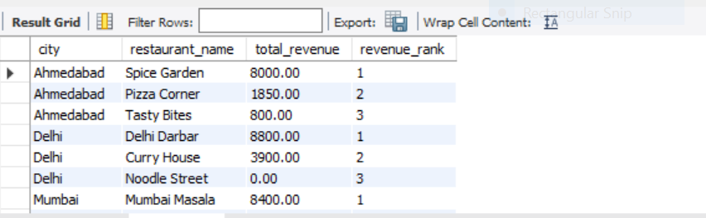

Window function: Each customer's most recent order
WITH customer_orders AS (
SELECT
c.customer_id,
c.customer_name,
o.order_id,
o.order_date,
r.restaurant_name,
o.order_amount,
ROW_NUMBER() OVER (
PARTITION BY c.customer_id
ORDER BY o.order_date DESC, o.order_id DESC
) AS rn
FROM customer c
LEFT JOIN orders o
ON c.customer_id = o.customer_id
LEFT JOIN restaurant r
ON o.restaurant_id = r.restaurant_id
)
SELECT
customer_id,
customer_name,
order_id,
order_date,
restaurant_name,
order_amount
FROM customer_orders
WHERE rn = 1
ORDER BY customer_id;

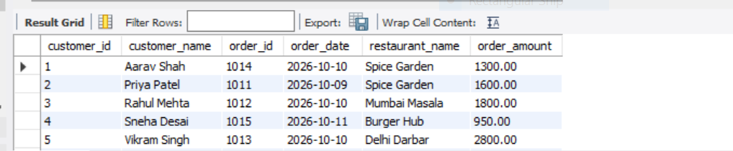

Create the SQL View
CREATE OR REPLACE VIEW vw_daily_order_summary AS
SELECT
o.order_date
c.customer_name,
r.restaurant_name,
da.agent_name,
o.order_amount,
o.delivery_time_mins
FROM orders o
INNER JOIN customer c
ON o.customer_id = c.customer_id
INNER JOIN restaurant r
ON o.restaurant_id = r.restaurant_id
INNER JOIN delivery_agents da
ON o.agent_id = da.agent_id;

Query the view for the last 7 days
SELECT
order_date,
customer_name,
restaurant_name,
agent_name,
order_amount,
delivery_time_mins
FROM vw_daily_order_summary
WHERE order_date >= CURRENT_DATE - INTERVAL 6 DAY
AND order_date < CURRENT_DATE + INTERVAL 1 DAY
ORDER BY order_date DESC;

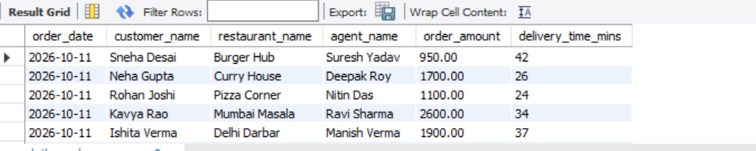

Final project checklist
Project completion
Created four related tables with primary and foreign keys
Inserted 10 customers, 10 restaurants, 10 delivery agents and 20 orders
Used JOIN, GROUP BY, HAVING, SUM, COUNT and AVG
Classified customers using CASE WHEN
Ranked restaurants using DENSE_RANK()
Found each customer's latest order using ROW_NUMBER()
Created and queried vw_daily_order_summary
Conclusion: This mini capstone demonstrates how SQL can support food delivery business decisions by analyzing restaurant revenue, customer spending, restaurant rankings, order history, and delivery performance using a relational database.
Section D — AI-Augmented Learning Section D — AI-Augmented Learning
### D: SECTION D:
STEP 1-AI Augmented Learning
STEP 1 · BUILD WITH AI
Use an AI tool of your choice (ChatGPT, Claude, GitHub Copilot, etc.) to help you write a SQL query
that:
Finds the top 3 delivery agents per city for a food delivery platform, ranked by number of
completed orders, using window functions.
Includes a column showing each agent's average delivery time alongside their rank.
Filters the result to include only agents who have completed more than 5 orders in that city.
Returns the final output sorted by city name alphabetically, then by rank ascending.
use mydb;
drop table if exists deliveries;
CREATE TABLE deliveries (
delivery_id INT PRIMARY KEY,
agent_name VARCHAR(100),
city VARCHAR(100),
order_status VARCHAR(30),
delivery_time_mins INT
);

select * from deliveries;
WITH agent_stats AS ( SELECT city, agent_name, COUNT(delivery_id) AS completed_orders, AVG(delivery_time_mins) AS avg_delivery_time FROM deliveries WHERE order_status = 'Completed' GROUP BY city, agent_name HAVING COUNT(delivery_id) > 5 ), ranked_agents AS ( SELECT city, agent_name, completed_orders, avg_delivery_time, ROW_NUMBER() OVER ( PARTITION BY city ORDER BY completed_orders DESC, agent_name ASC ) AS agent_rank FROM agent_stats ) SELECT city, agent_name, completed_orders, ROUND(avg_delivery_time, 2) AS avg_delivery_time, agent_rank FROM ranked_agents WHERE agent_rank <= 3 ORDER BY city ASC, agent_rank ASC;

INSERT INTO deliveries (delivery_id, agent_name, city, order_status, delivery_time_mins) VALUES (1, 'Amit', 'Ahmedabad', 'Completed', 25), (2, 'Amit', 'Ahmedabad', 'Completed', 30), (3, 'Amit', 'Ahmedabad', 'Completed', 28), (4, 'Amit', 'Ahmedabad', 'Completed', 22), (5, 'Amit', 'Ahmedabad', 'Completed', 35), (6, 'Amit', 'Ahmedabad', 'Completed', 27), (7, 'Priya', 'Ahmedabad', 'Completed', 20), (8, 'Priya', 'Ahmedabad', 'Completed', 24), (9, 'Rahul', 'Mumbai', 'Completed', 32), (10, 'Rahul', 'Mumbai', 'Cancelled', NULL);

SELECT
city,
agent_name,
COUNT(*) AS completed_orders
FROM deliveries
WHERE order_status = 'Completed'
GROUP BY city, agent_name
ORDER BY city, completed_orders DESC;Ans:
— — AI-Augmented Learning AI-Augmented Learning
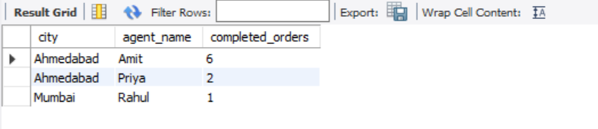
WITH agent_stats AS ( SELECT city, agent_name, COUNT(delivery_id) AS completed_orders, AVG(delivery_time_mins) AS avg_delivery_time FROM deliveries WHERE order_status = 'Completed' GROUP BY city, agent_name HAVING COUNT(delivery_id) > 5 ), ranked_agents AS ( SELECT city, agent_name, completed_orders, avg_delivery_time, ROW_NUMBER() OVER ( PARTITION BY city ORDER BY completed_orders DESC, agent_name ASC ) AS agent_rank FROM agent_stats ) SELECT city, agent_name, completed_orders, ROUND(avg_delivery_time, 2) AS avg_delivery_time, agent_rank FROM ranked_agents WHERE agent_rank <= 3 ORDER BY city ASC, agent_rank ASC;
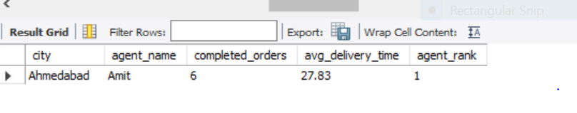

Step 2 — Test and Debug Without AI
1)
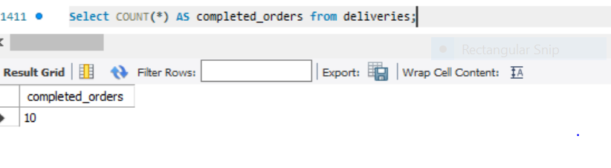
2)
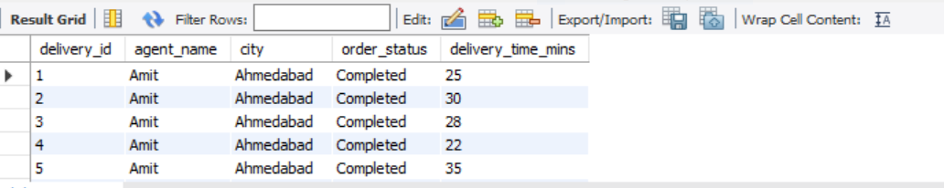
3)

Select delivery_id, agent_name, order_status from deliveries
where Order_status = "Completed";


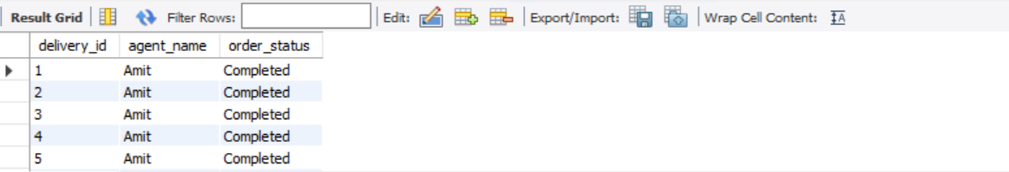

4) 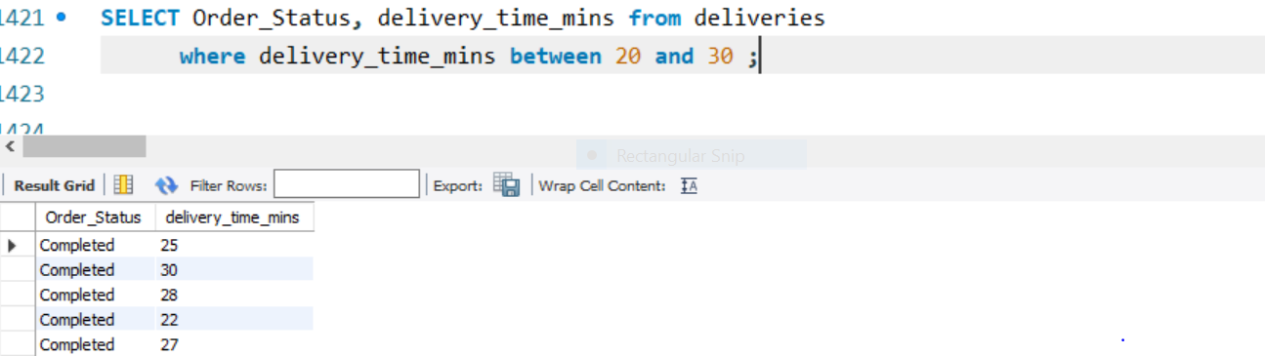

5) 